## A Student Table:
Student_ID Stu_Name Stu_Subject _ID Stu_Marks Stu_Age
101 Akhil BCA101 85 20
102 Balram BCA104 78 19
103 Bheem BCA102 80 22
104 Chetan BCA103 95 20
105 Diksha BCA104 99 20
106 Raman BCA105 88 19
107 Sheetal BCA103 98 22

Subject Table:

Subject_ID Subject_Name
BCA101 C
BCA102 C++
BCA103 Principle of Management
BCA104 Core Java
BCA105 Math
BCA106 Android

Query 1: Write a query to create the table in Structured Query Language.
Query 2: Write a query to insert the data into the table.
Query 3: Write a query to view the specific record of the table by using the WHERE clause.
Query 4: Write a query in SQL to find the minimum and maximum number from the integer column:
Query 5: Write a query to access the first record from the SQL table?
Query 6: Write a query to access the last record from the table?
Query 7: Write a query to access the first Nth rows from the table?
Query 8: Write a query to access the last Nth rows from the SQL table?
Query 9: Write a query to show the record of those students whose name begins with the 'm' character
Query 10: Write a query in structured query language to view all student details from the Student table order by Stu_Name Descending.

##B

EmployeeID | FirstName | LastName | Department | Salary
1 | John | Smith | HR | 50000
2 | Jane | Doe | IT | 60000
3 | Bob | Johnson | Finance | 55000
4 | Mary | Brown | IT | 62000
5 | Alice | White | Sales | 48000

SQL Questions :
1. *Question: Retrieve the first and last names of all employees.
2. *Question: List the employees who work in the IT department.
3. *Question: Calculate the average salary of all employees.
4. *Question: Find the highest salary among all employees.
5. *Question:* Count the number of employees in each department.
6. *Question:* Retrieve the employees with salaries greater than $55,000 and in the HR or Finance department.
7. *Question:* List the employees with names containing "a" in their first name.
8. *Question:* Calculate the total salary expenditure for the company.
9. *Question:* Find the employee with the lowest salary.
10. *Question:* Update the salary of Bob Johnson to $56000
##C
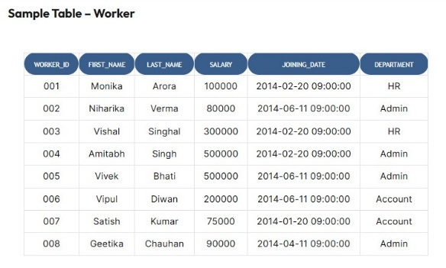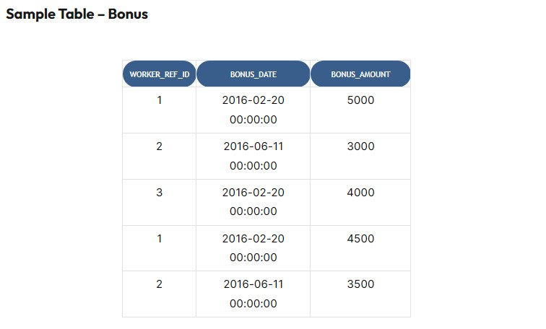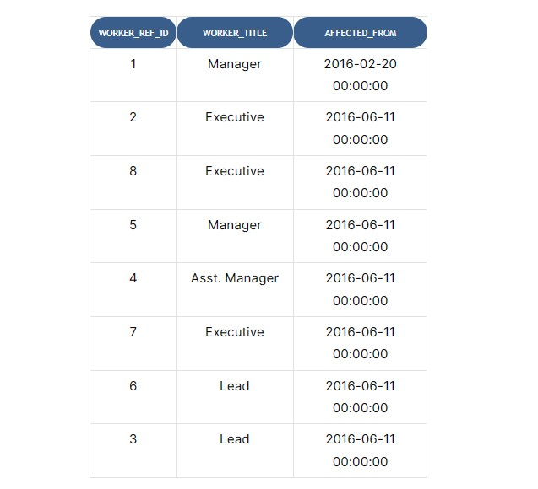

Q-1. Write an SQL query to fetch “FIRST_NAME” from the Worker table using the alias name <WORKER_NAME>.
Q-2. Write an SQL query to fetch “FIRST_NAME” from the Worker table in upper case.
Q-3. Write an SQL query to fetch unique values of DEPARTMENT from the Worker table.
Q-4. Write an SQL query to print all Worker details from the Worker table order by FIRST_NAME Ascending.
Q-5. Write an SQL query to print all Worker details from the Worker table order by FIRST_NAME Ascending and DEPARTMENT Descending.
Q-6. Write an SQL query to print details for Workers with the first names “Vipul” and “Satish” from the Worker table.
Q-7. Write an SQL query to print details of workers excluding first names, “Vipul” and “Satish” from the Worker table.
Q-8. Write an SQL query to print details of the Workers whose FIRST_NAME contains ‘a’.
Q-9. Write an SQL query to print details of the Workers whose SALARY lies between 100000 and 500000
Q-10. Write an SQL query to fetch the no. of workers for each department in descending order.
##D
- How do you select all columns from a table named "employees"?
Answer: |  | SELECT * FROM employees;
- What is the SQL command to retrieve unique values from a column named
"city" in a table named "customers"?
Answer: |  | SELECT DISTINCT city FROM customers;
- How do you count the number of records in a table named "orders"?
Answer: |  | SELECT COUNT(*) FROM orders;
- What is the SQL command to retrieve all orders placed by a specific customer with the ID 123?
Answer: |  | SELECT * FROM orders WHERE customer_id = 123;
- How do you retrieve the first 10 records from a table named "products"?
Answer: |  | SELECT * FROM products LIMIT 10;
- What is the SQL command to update the "price" column of a product with ID 456 to $20.99?
Answer: |  | UPDATE products SET price = 20.99 WHERE product_id =
456;
- How can you delete all records from a table named "employees" where the "department" is "HR"?
Answer: |  | DELETE FROM employees WHERE department = 'HR';
- What is the SQL command to retrieve the average salary of all employees in the "salary" column of a table named "employees"?
Answer: |  | SELECT AVG(salary) FROM employees;
- How do you retrieve the names of customers whose names start with the letter "A"?
Answer: |  | SELECT name FROM customers WHERE name LIKE 'A%';
- What is the SQL command to join two tables "orders" and "customers" on the "customer_id" column?
Answer: |  | SELECT * FROM orders INNER JOIN customers ON
orders.customer_id = customers.customer_id;

##E
Employee_num | Employee_name | Department | Salary
1 | Amit | CSE | 680000
2 | Rishi | CSE | 550000
3 | Prianka | CSE | 430000

Write a query to create the table in Structured Query Language.

Write a query to insert data into the table.

Write a query to view the specific record of the table by using the WHERE clause?

Write a query that access the first the second record from the SQL table?

Write a query to find second highest Salary of Employee?

Write a query how to find monthly salary of Employee if annual salary is given?

Write an SQL query to find the maximum, minimum, and average salary of the employees.

Write an SQL query to find the employee id whose salary lies in the range of 600000 and 690000.

. Write an SQL query to fetch common records between two tables.

Write an SQL query to fetch records that are present in one table but not in another table.
##F
StudentID | FirstName | LastName | Age | GPA | Major
10001 | John | Doe | 20 | 3.75 | Computer Science
10002 | Jane | Smith | 21 | 3.90 | Mathematics
10003 | Alice | Johnson | 22 | 3.60 | Physics
10004 | Bob | Wilson | 19 | 3.45 | Chemistry
10005 | Emily | Brown | 20 | 3.85 | Biology
10006 | Sarah | Lee | 21 | 3.70 | Computer Science
10007 | David | Anderson | 22 | 3.55 | Mathematics
Student Table Questions:
- How do you retrieve all records from the 'Student' table?
- What SQL statement would you use to filter students who are older than 20?
- How do you retrieve students whose first name starts with 'A'?

- What SQL statement would you use to update the GPA of a student with 'StudentID' 10002?
- How do you delete a student with 'StudentID' 10005 from the 'Student' table?
- What is the purpose of an index, and how can you create an index on the 'Major' column?
- Write an SQL query to find the student id whose age lies in the range of 20 and 21.
- Write an SQL query to fetch the last five records from a table
- Retrieve the student(s) with the highest GPA
- How would you insert a new student record into the 'Student' table?
##G
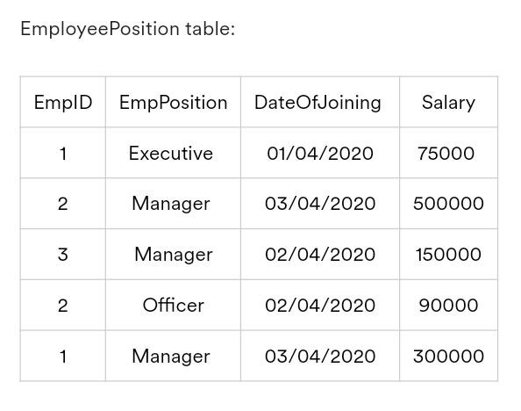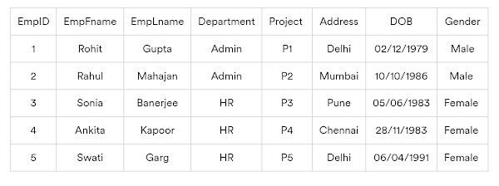
1.Write a query to get the EmpFname from the EmployeeInfo table in the upper case using the alias name as EmpName.
2.Write a query to get the number of employees working in the department ‘HR’.
3.What query will you write to fetch the current date?
4.Write a query to fetch only the place name(string before brackets) from the Address column of the EmployeeInfo table.
5.Write a query to create a new table whose data and structure are copied from another table.
6.Write a query to display the names of employees that begin with ‘S’.
7.Create a query to obtain display employees having salaries equal to or greater than 150000.
8.Write a query to fetch the year using a date.
9.Write a query to find duplicate records from a table.
10.Create a query to fetch the list of employees of the same department.
##H
Empid | EmpName | Department | ContactNo | EmailId | EmpHeadId
101 | Isha | E-101 | 1234567890 | isha@gmail.com | 105
102 | Priya | E-104 | 1234567890 | priya@yahoo.com | 103
103 | Neha | E-101 | 1234567890 | neha@gmail.com | 101
104 | Rahul | E-102 | 1234567890 | rahul@yahoo.com | 105
105 | Abhishek | E-101 | 1234567890 | abhishek@gmail.com | 102

Queries:-

1. Select the detail of the employee whose name start with P.

2. Select the detail of employee whose emailId is in gmail.

3. Select the details of the employee who work either for department E-104 or E-102.

4. What is the department name for DeptID E-102?

5. List name of all employees whose name ends with a.

EmployeeInfo Table:
EmpID | EmpFname | EmpLname | Department | Project | Address | DOB | Gender
1 | Sanjay | Mehra | HR | P1 | Hyderabad(HYD) | 01/12/1976 | M
2 | Ananya | Mishra | Admin | P2 | Delhi(DEL) | 02/05/1968 | F
3 | Rohan | Diwan | Account | P3 | Mumbai(BOM) | 01/01/1980 | M
4 | Sonia | Kulkarni | HR | P1 | Hyderabad(HYD) | 02/05/1992 | F
5 | Ankit | Kapoor | Admin | P2 | Delhi(DEL) | 03/07/1994 | M

EmployeePosition Table:
EmpID | EmpPosition | DateOfJoining | Salary
1 | Manager | 01/05/2022 | 500000
2 | Executive | 02/05/2022 | 75000
3 | Manager | 01/05/2022 | 90000
2 | Lead | 02/05/2022 | 85000
1 | Executive | 01/05/2022 | 300000

6. Write a query to find the Nth highest salary from the table without using TOP/limit keyword.

7.Write a query to retrieve duplicate records from a table.

8.Write a query to display the first and the last record from the EmployeeInfo table.

9. Write a query to retrieve two minimum and maximum salaries from the EmployeePosition table.

10.Write a query to calculate the even and odd records from a table.

##I
CREATE DATABASE student_inquery;
SHOW DATABASES;
USE student_inquery;

CREATE TABLE student (
Student_id INT(8) NOT NULL PRIMARY KEY,
First_name CHAR(25),
Last_name CHAR(25),
Money INT(15),
Money_source char(15),
Monthley_expenses int(8),
Department CHAR(25)
);

INSERT INTO student
(Student_id, First_name, Last_name,Money, Money_source, Monthley_expenses,Department) VALUES
(2002040, 'Shabuj', 'Mia',8000, 'Tution',7500, 'CSE'),
(2004067, 'Sorna', 'Boikontho', 5000, 'Home',4500, 'DVM'),
(2002022, 'Ronok', 'Hasan', 300000, 'Freelancing',11000 ,'CSE'),
(1902089, 'Amitabh', 'Reza', 500000, 'Freelancing',12350, 'ECE'),
(1804089, 'Fazle', 'Rabbi', 11500, 'Tution',6700, 'Agri'),
(1706044, 'Shanti', 'Rehman',70000, 'Home',6000, 'Act'),
(2107023, 'Rahman', 'Pair', 45000, 'Remote Job',16000, 'Engin.'),
(2205066, 'Geetika', 'Roy', 4500, 'Tution',4500, 'Math');

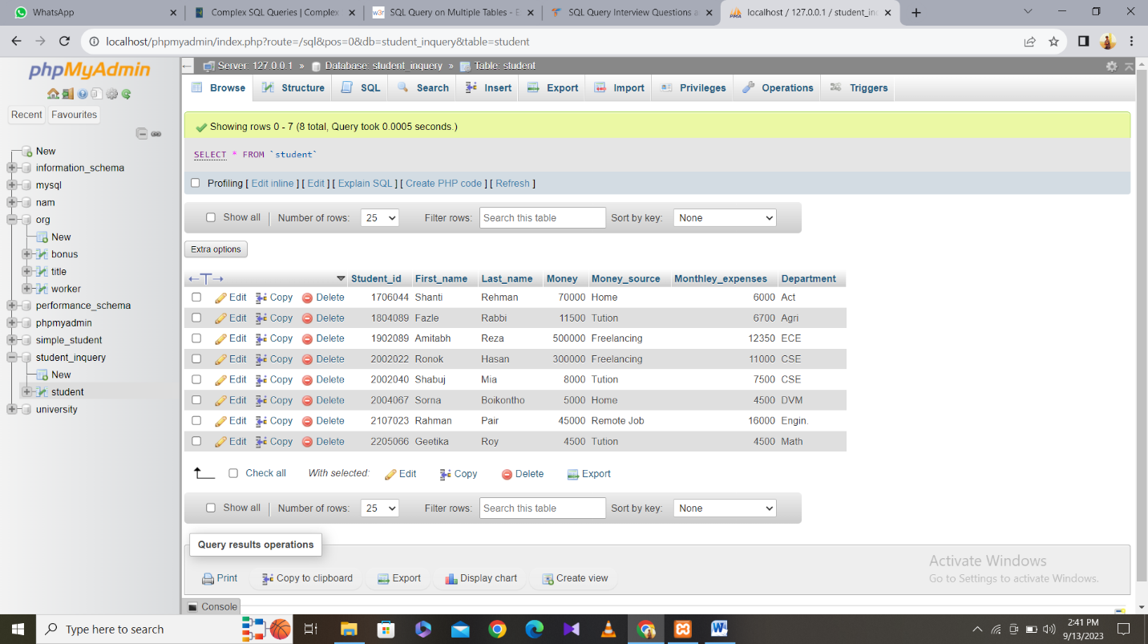

Q(1): What is SQL Query ? Why it is needed ? write it’s application.
Q(2): Write a SQL query to print First_name and Last_name from table into a single column Full_name.A space char should separate them.
Q(3): Write a SQL query to find those student money is greater than 10000 and expenses is greater than 10000.
Q(4): Write a SQL query to find those student expenses is smaller than 70000.
Q(5): Write a SQL query to find unique money source.
Q(6): Write a SQL query to find highest money in freelancing.
Q(7): Write a SQL query to find highest money in different job. Like (Home 7000, Freelancing 50000)
Q(8): Write a SQL query to find details for First_name “Ronok” Last_name “Hasan” from the table.
Q(9): Write a SQL query to find even Student_id.
Q(10): write a SQL query to find those student whose First_name start with “A” or “S”.

##J
WORKER_ID | FIRST_NAME | LAST_NAME | SALARY | JOINING_DATE | DEPARTMENT
001 | Monika | Arora | 100000 | 2014-02-20 09:00:00 | HR
002 | Niharika | Verma | 80000 | 2014-06-11 09:00:00 | Admin
003 | Vishal | Singhal | 300000 | 2014-02-20 09:00:00 | HR
004 | Amitabh | Singh | 500000 | 2014-02-20 09:00:00 | Admin
005 | Vivek | Bhati | 500000 | 2014-06-11 09:00:00 | Admin
006 | Vipul | Diwan | 200000 | 2014-06-11 09:00:00 | Account
007 | Satish | Kumar | 75000 | 2014-01-20 09:00:00 | Account
008 | Geetika | Chauhan | 90000 | 2014-04-11 09:00:00 | Admin

Sample Table – Worker

Sample Table – Bonus
WORKER_REF_ID | BONUS_DATE | BONUS_AMOUNT
1 | 2016-02-20 00:00:00 | 5000
2 | 2016-06-11 00:00:00 | 3000
3 | 2016-02-20 00:00:00 | 4000
1 | 2016-02-20 00:00:00 | 4500
2 | 2016-06-11 00:00:00 | 3500

Sample Table – Title
WORKER_REF_ID | WORKER_TITLE | AFFECTED_FROM
1 | Manager | 2016-02-20 00:00:00
2 | Executive | 2016-06-11 00:00:00
8 | Executive | 2016-06-11 00:00:00
5 | Manager | 2016-06-11 00:00:00
4 | Asst. Manager | 2016-06-11 00:00:00
7 | Executive | 2016-06-11 00:00:00
6 | Lead | 2016-06-11 00:00:00
3 | Lead | 2016-06-11 00:00:00

1.Write an SQL query to print all Worker details from the Worker table order by FIRST_NAME Ascending and DEPARTMENT Descending.

2.Write an SQL query to print details of Workers with DEPARTMENT name as “Admin”.

3. Write an SQL query to print details of workers excluding first names, “Vipul” and “Satish” from the Worker table.

4.Write an SQL query to print details of the Workers whose SALARY lies between 100000 and 500000.

5. Write an SQL query to fetch the no. of workers for each department in descending order.

6.Write an SQL query to fetch duplicate records having matching data in some fields of a table.

7. Write an SQL query to show only even rows from a table.

8. Write an SQL query to fetch intersecting records of two tables.

9.Write an SQL query to show records from one table that another table does not have.

10.Write an SQL query to show the top n (say 10) records of a table.

